# **How to Get Started With Python?**

#### In this tutorial, you will learn to install and run Python on your computer. Once we do that, we will also write our first Python program.

Python is a cross-platform programming language, which means that it can run on multiple platforms like Windows, macOS, Linux, and has even been ported to the Java and .NET virtual machines. It is free and open-source.

Even though most of today's Linux and Mac have Python pre-installed in it, the version might be out-of-date. So, it is always a good idea to install the most current version.

## **The Easiest Way to Run Python**

The easiest way to run Python is by using Thonny IDE.

The Thonny IDE comes with the latest version of Python bundled in it. So you don't have to install Python separately.

Follow the following steps to run Python on your computer.

1. Download [Thonny IDE](https://thonny.org/).
2. Run the installer to install Thonny on your computer.
3. Go to: File > New. Then save the file with .py extension. For example, hello.py, example.py, etc.  
   You can give any name to the file. However, the file name should end with .py
4. Write Python code in the file and save it.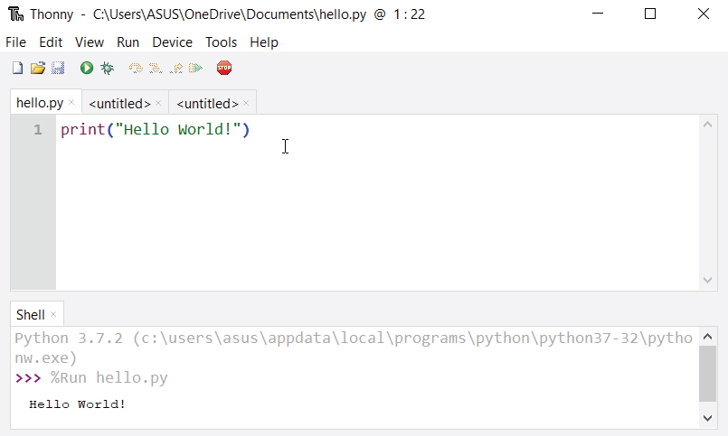Running Python using Thonny IDE
5. Then Go to Run > Run current script or simply click F5 to run it.

## **Install Python Separately**

If you don't want to use Thonny, here's how you can install and run Python on your computer.

1. Download the [latest version of Python](https://www.python.org/downloads/).
2. Run the installer file and follow the steps to install Python  
   During the install process, check Add Python to environment variables. This will add Python to environment variables, and you can run Python from any part of the computer.  
   Also, you can choose the path where Python is installed.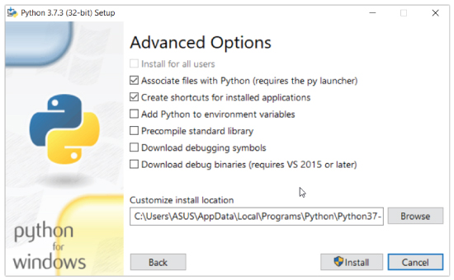Installing Python on the computer

Once you finish the installation process, you can run Python.

### **1. Run Python in Immediate mode**

Once Python is installed, typing python in the command line will invoke the interpreter in immediate mode. We can directly type in Python code, and press Enter to get the output.

Try typing in 1 + 1 and press enter. We get 2 as the output. This prompt can be used as a calculator. To exit this mode, type quit() and press enter.

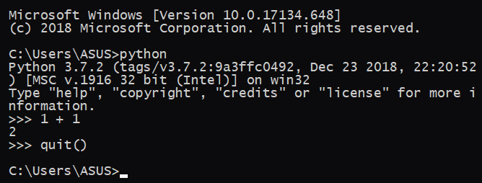Running Python on the Command Line

### **2. Run Python in the Integrated Development Environment (IDE)**

We can use any text editing software to write a Python script file.

We just need to save it with the .py extension. But using an IDE can make our life a lot easier. IDE is a piece of software that provides useful features like code hinting, syntax highlighting and checking, file explorers, etc. to the programmer for application development.

By the way, when you install Python, an IDE named IDLE is also installed. You can use it to run Python on your computer. It's a decent IDE for beginners.

When you open IDLE, an interactive Python Shell is opened.

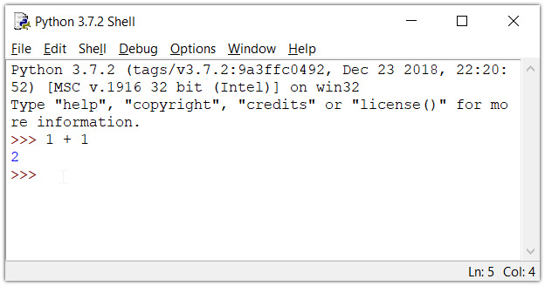Python IDLE

Now you can create a new file and save it with .py extension. For example, hello.py

Write Python code in the file and save it. To run the file, go to Run > Run Module or simply click F5.

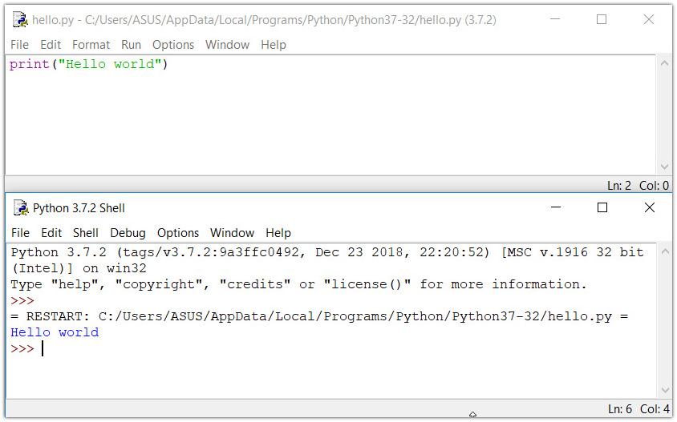Running a Python program in IDLE

## **Your first Python Program**

Now that we have Python up and running, we can write our first Python program.

Let's create a very simple program called Hello World. A "Hello, World!" is a simple program that outputs Hello, World! on the screen. Since it's a very simple program, it's often used to introduce a new programming language to beginners.

Type the following code in any text editor or an IDE and save it as hello_world.py

print("Hello, world!")

Then, run the file. You will get the following output.

Hello, world!